Project - High Level Design
on
Non-Profit Quiz/Tutor Bot
Course Name: Datagami Skill Based Course

Institution Name: Medicaps University

Student Name(s) & Enrolment Number(s):
Sr no | Student Name | Enrolment Number
1 | Bharat Rathore | EN22CS301260
2 | Avantika Gupta | EN22CS301242
3 | Chiran Vikram Shahi | EN22CS301301
4 | Devansh Gupta | EN22CS301325
5 | Chetan Oswal | EN22CS301295
6 | Deepali Pastariya | EN22CS301318

Group Name: 11D3
Project Number: GAI-35 Industry Mentor Name: Mr. Suraj Nayak
University Mentor Name: Prof. Vineeta Rathore
Academic Year: 2025-26

Table of Contents
1. Introduction. | 1.1. Scope of the document.  1.2. Intended Audience  1.3. System overview.
2. System Design. | 2.1. Application Design  2.2. Process Flow.  2.3. Information Flow.  2.4. Components Design  2.5. Key Design Considerations  2.6. API Catalogue.
3. Data Design. | 3.1. Data Model  3.2. Data Access Mechanism  3.3. Data Retention Policies  3.4. Data Migration
4. Interfaces
5. State and Session Management
6. Caching
7. Non-Functional Requirements | 7.1. Security Aspects  7.2. Performance Aspects
8. References

1. INTRODUCTION
The Non-Profit Quiz / Tutor Bot is an AI-powered web-based assessment system designed to evaluate and improve donor email communication strategies used by nonprofit organizations. The system leverages multimodal artificial intelligence, vector embeddings, and a retrieval-based architecture to transform donor email screenshots into an interactive learning and evaluation experience.
The platform extracts donor email text from uploaded screenshots, stores it in a vector database for contextual understanding, and generates expert-level multiple-choice questions (MCQs). These questions focus on persuasion techniques, emotional storytelling, donor psychology, call-to-action (CTA) effectiveness, ethical messaging, and communication weaknesses.
The system functions both as:
- A learning tutor (providing explanations and feedback)
- An assessment tool (scoring and evaluating understanding)
This High-Level Design (HLD) document describes the overall architecture, system components, workflow, and design approach of the solution.

1.1 Scope of the Document
This document provides a high-level design overview of the Non-Profit Quiz / Tutor Bot system. It includes:
- Overall system architecture
- Major system components and their responsibilities
- Data flow between modules
- Technology stack used
- Integration of AI models and vector database
- Functional behaviour of the system This document does not include:
- Low-level code implementation details
- Database schema definitions
- Deployment configuration specifics
- Detailed API specifications

1.2 Intended Audience
This document is intended for:
- Project evaluators and academic reviewers
- Software developers and system architects
- AI/ML engineers
- Technical stakeholders
- Nonprofit technology consultants
- Anyone interested in understanding the architecture of the system
It provides sufficient technical detail for understanding the system design while remaining at a high-level abstraction suitable for architectural review.

1.3 System Overview
The Non-Profit Quiz / Tutor Bot is a web-based application built using Streamlit as the frontend interface. It integrates multiple AI and data components to deliver an intelligent evaluation experience.
Core Workflow:
- User Upload
o Users upload donor email screenshots (PNG/JPG/JPEG).
- Text Extraction
o A multimodal AI model (Gemini 2.5 Flash) extracts donor email text from images.
- Embedding Generation
o The extracted text is converted into vector embeddings using a Sentence Transformer model.
- Vector Storage & Retrieval
o The embeddings are stored in a ChromaDB vector database.
- AI-Based Question Generation
o The AI model generates deep evaluation MCQs in structured JSON formate.
- Interactive Quiz Interface
- Users answer questions.
- The system evaluates responses.
O Instant feedback and explanations are provided.
- Final Evaluation
o Score calculation
o Performance percentage
o Qualitative performance feedback
Key System Characteristics:
- AI-driven content analysis
- Retrieval-Augmented Generation (RAG) approach
- Interactive assessment workflow
- Real-time feedback mechanism
The system transforms static donor emails into a structured educational tool that enhances communication quality awareness within nonprofit organizations.

2. System Design
The Non-Profit Quiz / Tutor Bot follows a modular and layered architecture integrating a web interface, AI models, embedding generation, and a vector database. The system uses a Retrieval-Augmented Generation (RAG) approach to extract donor email content, retrieve contextual information, and generate evaluation-based quizzes.

2.1 Application Design
The application consists of four main layers:
- Presentation Layer: Built using Streamlit for user interaction (file upload, quiz display, scoring).
- AI Processing Layer: Gemini model for text extraction and question generation.
- Embedding Layer: SentenceTransformer to convert text into vector embeddings.
- Data Layer: ChromaDB to store and retrieve contextual donor emails.

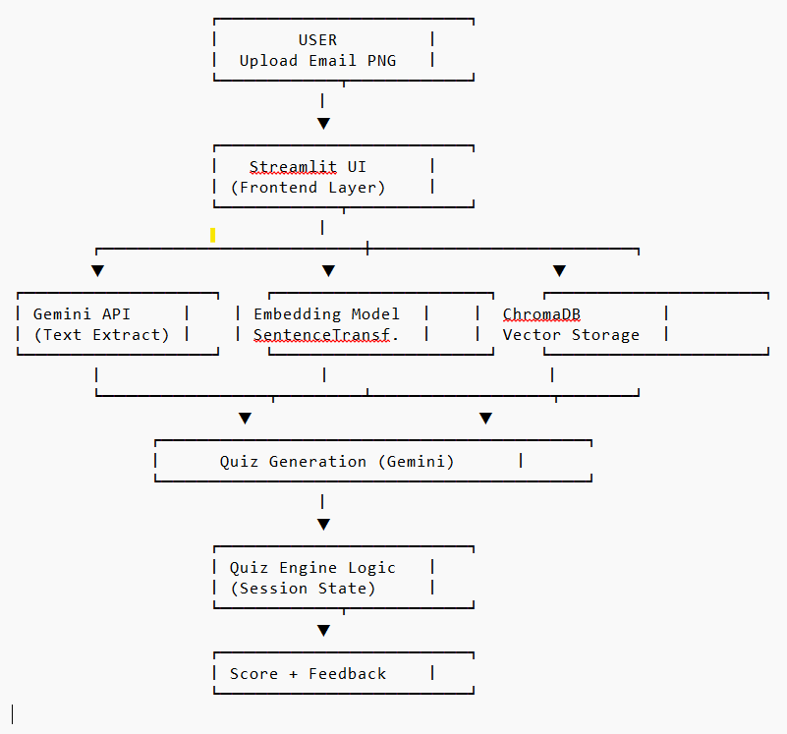 Figure 2.1.1 Application Design

2.2 Process Flow
- User uploads donor email screenshots.
- AI extracts email text from images.
- Text is converted into embeddings.
- Embeddings are stored in ChromaDB.
- Relevant context is retrieved.
- AI generates MCQs in JSON format.
- User answers questions and receives feedback.
- Final score and evaluation are displayed.

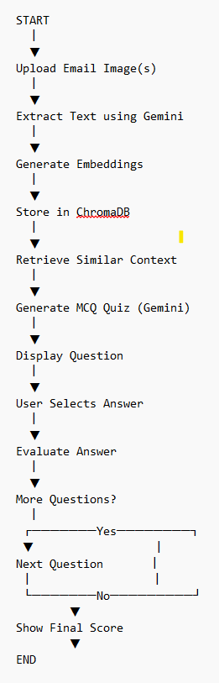
Figure 2.2.1 Process Flow Design

2.3 Information Flow
Image → AI Text Extraction → Text
Text → Embedding Model → Vector Database
Vector Database → Retrieved Context → AI Question Generation
AI → Quiz JSON → UI → User Response → Score Calculation

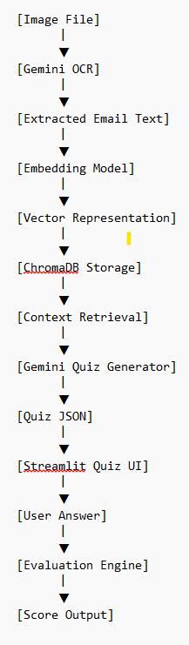
Figure 2.3.1 Information Flow Design

2.4 Components Design
- UI Component (Streamlit) – Handles interaction and quiz display.
- AI Component (Gemini) – Extracts text and generates questions.
- Embedding Component – Converts text to semantic vectors.
- Vector Database (ChromaDB) – Stores and retrieves embeddings.
- Evaluation Engine – Validates answers and calculates score.

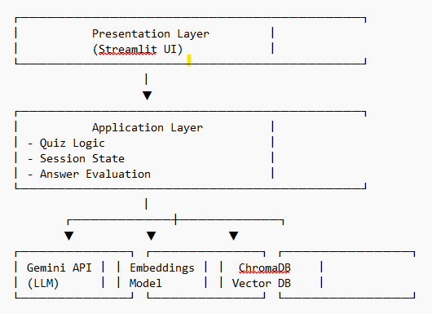
Figure 2.4.1 Components Design

2.5 Key Design Considerations
- Scalability using modular architecture
- Accurate contextual retrieval using embeddings
- Real-time feedback mechanism
- Error handling for AI JSON responses
- Maintainable and loosely coupled components

2.6 API Catalogue
API /  Service | Purpose | Method / Function  Used | Input | Output
Gemini API | Extract donor email text from images and generate quiz questions | client.models.generate_ content() | Image  files /  Prompt  text | Extracted email text /  MCQs in JSON  format
SentenceTr ansformer | Generate semantic vector embeddin gs from text | embedding_model.enc ode() | Extract ed email text | Vector embeddings  (float arrays)
ChromaDB  API | Store and retrieve vector embeddin  gs | get_or_create_collectio n(), add(), query() | Embed  dings and  docum  ents | Retrieved contextual documents
Streamlit  Framework | User interface and state  manageme  nt | st.file_uploader(), st.button(), st.radio(), st.session_state | User actions and inputs | Interactive UI and quiz flow

3. Data Design
The system manages both structured and unstructured data. Unstructured data includes donor email screenshots and extracted text, while structured data includes quiz questions, embeddings, user responses, and scoring information.
The system uses vector embeddings for semantic retrieval and session-based storage for quiz state management.

3.1 Data Model
The system handles the following data entities:

1. Email Data
- Email Image (PNG/JPG)
- Extracted Email Text (String)

2. Embedding Data
- Email Text
- Vector Embedding (List of float values)
- Unique ID (UUID)

3. Quiz Data (JSON Structure)
- Question (String)
- Options (Array of 4 strings)
- Correct Answer (String)
- Explanation (String)

4. User Session Data
- Current Question Index
- Selected Answer
- Score
- Feedback Status

ChromaDB stores:
- Document (Email text)
- Embedding
- ID
Streamlit session state stores temporary quiz-related data.

3.2 Data Access Mechanism
The system accesses data through:

- Vector Retrieval:
  - Embeddings are generated using SentenceTransformer.
  - ChromaDB performs similarity search using query() to retrieve relevant email context.

- Session-Based Access:
  - Streamlit session_state stores quiz progress and scoring temporarily during runtime.

- AI-Based Data Processing:
  - Gemini API processes extracted and retrieved text to generate quiz questions.

3.3 Data Retention Policies
- Uploaded images are processed in memory and not permanently stored.
- Extracted email text and embeddings are stored in ChromaDB during runtime.
- Session data (quiz progress, score) is temporary and cleared after session ends.
- No personal donor information is intentionally retained long-term.
The system prioritizes minimal data storage and privacy.

3.4 Data Migration
Currently, the system operates on a local vector database (ChromaDB).
For future scalability:
- Data can be migrated to a cloud-based vector database.
- Embeddings can be exported and re-indexed.
- Model upgrades (embedding model or AI model) may require re-embedding stored documents.
The modular architecture allows smooth migration without major structural changes.

4. Interfaces
The system interacts with users and external services through the following interfaces:

4.1 User Interface
- Built using Streamlit (web-based UI).
- Allows users to:
- Upload donor email screenshots
- Select number of quiz questions
- Attempt quiz
- View feedback and final evaluation

4.2 External AI Interface
- Gemini API for:
O Multimodal text extraction
o Quiz generation
4.3 Vector Database Interface
- ChromaDB API for:
- Storing embeddings
- Performing similarity search
4.4 Embedding Interface
- SentenceTransformer model for converting text into vector embeddings.

5. State and Session Management
The system uses Streamlit session_state for managing runtime data.
Stored session parameters include:
- Generated quiz data
- Current question index
- Score
- Feedback visibility flag

6. Caching
Currently, the system performs real-time processing without advanced caching mechanisms.
Possible caching areas:
- Reuse of generated embeddings
- Caching AI responses for repeated prompts
- Streamlit’s built-in caching decorators (future enhancement)
- Caching can improve performance and reduce API calls.

7. Non-Functional Requirements
The system is designed to meet the following non-functional requirements:
- Usability
- Scalability
- Performance efficiency
- Reliability
- Security
- Maintainability

7.1 Security Aspects
- API key stored securely using environment variables (.env file).
- No permanent storage of uploaded images.
- Minimal retention of donor email content.
- No direct exposure of backend credentials.
- Controlled user input validation.

7.2 Performance Aspects
- Lightweight embedding model (MiniLM) ensures faster embedding generation.
- Vector similarity search enables efficient context retrieval.
- Streamlit session management
prevents unnecessary recomputation.
- Limited number of quiz questions (3–10) maintains fast response time.

Performance may depend on:
- Internet connectivity
- Gemini API response time
- System hardware capacity

8. References

- Google. (2024). Gemini API Documentation. Available at: https://ai.google.dev/docs
- Reimers, N., & Gurevych, I. (2019). Sentence-BERT: Sentence Embeddings using Siamese BERT-Networks.
Proceedings of the 2019 Conference on Empirical Methods in Natural Language Processing (EMNLP).
Available at: https://arxiv.org/abs/1908.10084
- SentenceTransformers Documentation. (2024). Available at: https://www.sbert.net
- ChromaDB Documentation. (2024). Available at: https://docs.trychroma.com
- Streamlit Documentation. (2024).
Available at: https://docs.streamlit.io
- Lewis, P., et al. (2020). Retrieval-Augmented Generation for Knowledge-Intensive NLP Tasks.
Advances in Neural Information Processing Systems (NeurIPS 2020).

